DEVGuide

Definition
# Source: ScreenShots Source: Provided by: [Persons Table -> ID Column: 1, Name_En Column: Motasem Essam] -> Tool: [Lightshot Program] -> From [Site: https://www.devguide.at] on [2/19/2026]

# Source: AI Source: Provided by: [Data Path: Persons Table -> ID Column: 1, Name_En Column: Motasem Essam] -> From: [ChatGPT] on [2/19/2026]
DEVGuide (https://www.devguide.at/en/) is a free online educational website that teaches the fundamentals of web development, servers, networking, and programming tools. It is designed mainly for beginners and intermediate learners who want to understand how modern web and server technologies work in practice.

Key Highlights
# Source: AI Source: Provided by: [Data Path: Persons Table -> ID Column: 1, Name_En Column: Motasem Essam] -> From: [ChatGPT] on [2/19/2026]
- Beginner-friendly explanations of technical concepts
- Covers full web stack basics (frontend + backend + infrastructure)
- Practical topics like Linux, Git, Docker, and web servers
- Includes cheat sheets and step-by-step guides
- Focus on real-world development and deployment rather than theory
- Free and accessible without registration

Summary Table
# Source: AI Source: Provided by: [Data Path: Persons Table -> ID Column: 1, Name_En Column: Motasem Essam] -> From: [ChatGPT] on [2/19/2026]
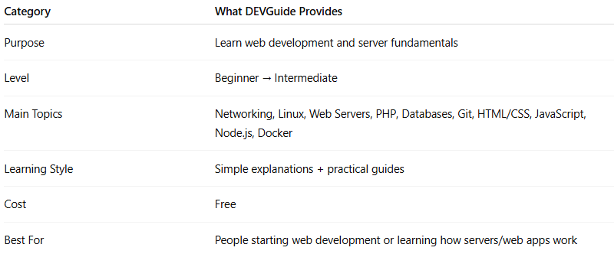
Category | What DEVGuide Provides
Purpose | Learn web development and server fundamentals
Level | Beginner → Intermediate
Main Topics | Networking, Linux, Web Servers, PHP, Databases, Git, HTML/CSS, JavaScript, Node.js, Docker
Learning Style | Simple explanations + practical guides
Cost | Free
Best For | People starting web development or learning how servers/web apps work

